

TENDER SALE - 2014 Hyundai Passenger Van

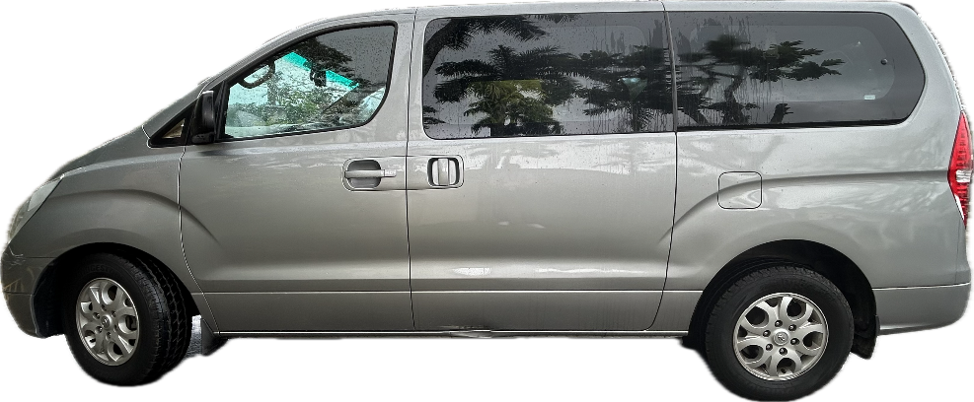
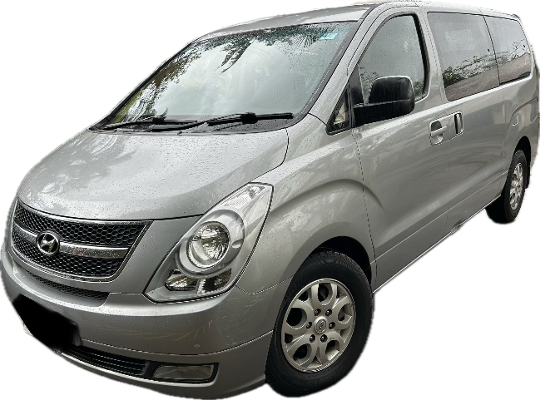

- 2014 Model | - 41,375 km
- 5-Speed Automatic | - Air-conditioning
- 2.5L Diesel Engine | - Power steering
- 8-Seater | - Full-service history (Carpenter/Chand’s Motors)

Sale Details
Vehicles may be viewed at the Australian High Commission, 37 Princes Road, Tamavua, Suva on Thursday 11 December 2025 between 9:00am and 4:00pm. Test drives are not permitted. Tender bids must be received no later than 4pm Thursday 11 December 2025.

The sale of the vehicles will be via sealed tender bid. Tender documents, including the tender bid template, can be accessed via https://fiji.embassy.gov.au/suva/Tender.html or in hard copy from the AHC during business hours. Only the successful bidders will be notified.

Enquiries relating to this tender can be directed to tenders.suva@dfat.gov.au

